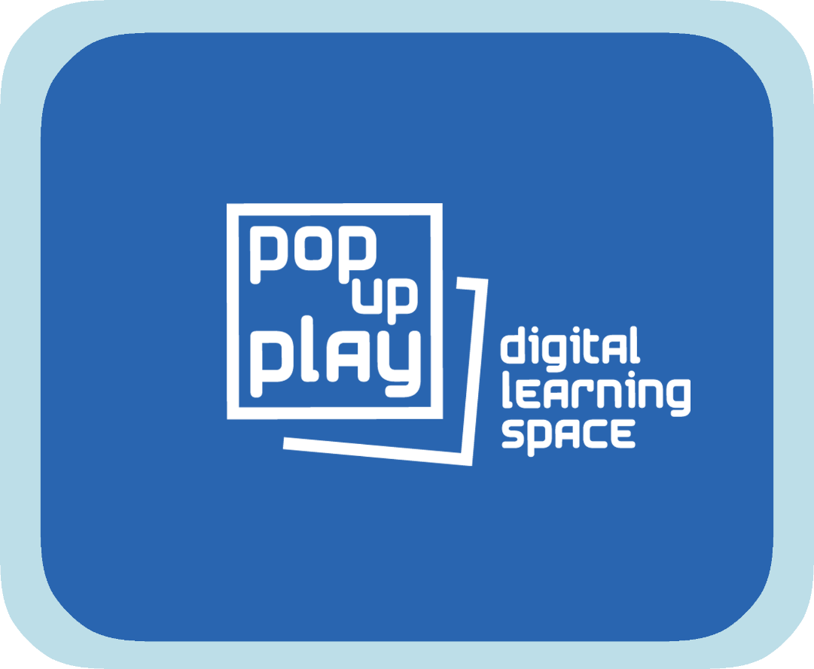
Pop Up Play Software User Manual

Summary 2
Hardware that may be used 3
Hardware notes 3
Third party software that will be needed 4
Installing and running the PUP software. 5
Minimum system requirements 5
Codecs and File Formats 6
Setting up equipment. 7
Basic Set-up – Computer, Kinect and Speakers 8
Full Set-up – 9
Opening the PUP Software 11
Connecting and using the IPad 12
WI-FI Set-up 12
Using the PUP software on a computer 12
Using the PUP software on an IPad 14
Adding media to the library 16
Troubleshooting 18
Additional information 19

Summary
The Pop Up Play (PUP) software facilitates the creation of a mixed reality environment where a combination of the digital and the real can come together to stimulate creative play and communication. It allows for participants to be immersed in scenarios that can be expanded upon with almost limitless possibilities.
The software makes use of interactive visual, audio and lighting elements which can be loaded up with media content as desired and combined with real time input for a very flexible system. The system attempts to use accessible and low cost technology and is designed to be modular so that a basic setup could consist of a small part of the available components, though at a reduced set of features.
The only restriction with the PUP system is how big your imagination is.
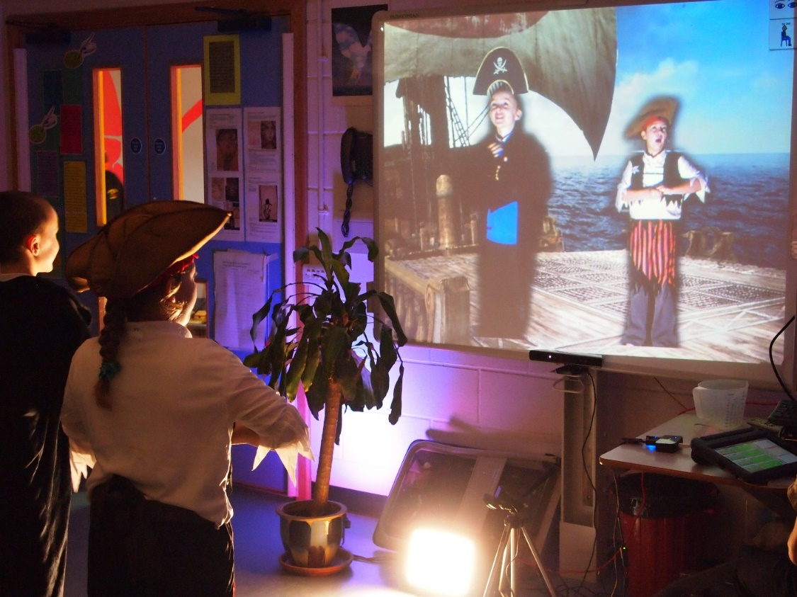

The system is comprised of 3 parts: a video system, an audio system, and a lighting system. All systems have a bank of selectable settings and media that can be linked together to provide one button scene changes. Adding the capability for accessible controls on the iPad enables the workshop leader to be mobile whilst running the session and also for the young people themselves to be able to take control.
The visual system makes use of a 3D depth sensor, namely the Kinect camera. This enable us to bring the participants into the screen whilst cutting out the background. From here we can mix elements of the digital and real world together and due to the body tracking capabilities of the Kinect camera we can also track items onto a users body or indeed do full body digital puppetry. The video system can also make use of a usb camera or visualiser as input enabling us to bring real world items into the digital environment.
The audio system gives us a bank of ambient background sounds and two further banks of sound effects that can be used over the top as well as microphone input. As with all parts of the system, all that is required to change or add to media, is to simply add or remove things from a folder structure and the software will pick them up. For example, users of the system could create their own body parts for a digital puppet and just copy them into a folder.
The lighting system is designed to work with 4x 6 channel RGB DMX fittings, though by setting up the DMX devices with the same addresses you could have any number with 4 individual output colours. The lighting system is very simple to use, traditionally unlike a dedicated DMX system. With the use of a single finger a user can scroll through all the colours of the rainbow effortlessly.

Potential Hardware
Within this guide are general set-up instructions for the software and hardware that PUP can make use of. Not all users will have the same hardware or software setup so specific items that you own may need to be configured using the manufacturers instructions. If you have any trouble setting up your hardware, then refer to the troubleshooting guide at the end of this document or online at: *weblink*. If you are still having trouble then the discussion board can be a useful source of help from the community: *weblink*
The list below shows the hardware that can be used with the system, though with it being modular it is not all required to run a basic setup:
Computer – Windows computer running at least Windows 7
Kinect v1 camera/sensor (see hardware notes)
or...
Kinect v2 camera/sensor – This model of the Kinect camera should only be used with computers running at least Windows 8 and with a USB3 port (see hardware notes)
Webcam
Mains powered USB Hub (may not be required if using limited setup or your computer has enough USB ports)
DMX Lighting control box (Enttec DMX-USB Pro or Pro 2)
DMX fixtures – 6 channel DMX lighting with a Red Green and Blue channel (e.g. par can, colour wash, RGB lighting bar etc)
Performer lighting – studio style lighting (eg LED panel, white umbrella style lights)
Projector and screen or large format monitor
Audio system (eg amp and speakers, PA system, active speakers)
iPad

Hardware notes
There are two types of Kinect Sensor available, the Kinect for Xbox and the Kinect for Windows. The use of software on Windows legally requires the Kinect for Windows and hence is what this system is designed for. Developers may use the Kinect for Xbox when contributing to the software, guidelines can be found here: *weblink*
The Kinect v1 model is of lower resolution than the v2 meaning that the cut out image of the performers may be of lower quality and may appear pixelated on large screens. The v2 also has tighter tracking and deals with lower light levels better, but this all comes at a cost. The v2 needs at least Windows 8, USB3 and uses more processing power so will require a higher spec machine.
Both models of Kinect require a lot of bandwidth on the USB port they are plugged into and therefore will not like sharing a hub with another camera, though they should work alongside the DMX interface. Sometimes a machine will have extra USB ports due to an internal hub so it is worth trying different hubs if there are any issues.

Installing and running the PUP software.
The PUP system is provided in the form of a zipped file which includes all the things you will need to make it run. It is advisory that you unzip and extract these files before use rather than run them directly from the zip folder. To do this, right click on the zip file and select 'Extract Files'.
The PUP software itself is a simple .exe file that can be moved to a location of your choosing and run. However, it does depend on some third party components in order to work properly and details of installing them follow.
[Developers - The PUP software was built in Cycling74's 'Max' programming environment. If you are interested in contributing to the PUP system please refer to the 'Developers' section of this manual]

Third party software required
To enable the full functionality of the PUP software, several pieces of third party software are required. At some point in the future we may be able to roll these all in to a single installer, but for now they are included as individual files. It doesn't particularly matter in which order you run these, and they may not all be required depending on your setup, but the software will not work fully without them all in place. Links to the original downloads are provided should you want more information.
AdHoc setup??

Apple QuickTime for Windows
The video engine of the PUP software currently makes use of QuickTime.
*weblink*

Apple Bonjour
To enable an iPad to communicate with the PUP software you will need to install Bonjour services.
http://support.apple.com/kb/DL999?viewlocale=en_US&locale=en_US

Kinect for Windows Runtime
If using the Kinect for Windows you will need to install the required software and drivers.
For Kinect v1, at the time of this manuals release, you will need version 1.8:
http://www.microsoft.com/en-gb/download/details.aspx?id=40277
For Kinect v2, at the time of this manuals release, you will need version 2.0:
http://www.microsoft.com/en-gb/download/details.aspx?id=44559

dp.kinect
This component enables us to speak to the Kinect Sensor and is actually included in the software so does not need to be installed, but a licence is required which will need to be purchased and registered. Depending on which version of the Kinect you are using you will need to buy a certain version, either dp.kinect for the v1 or dp.kinect2 for the v2.
Follow the link to purchase the appropriate licence:
https://hidale.com/product-category/software/

FTDI Drivers
To enable you to use the recommended lighting equipment you will need to install drivers that enable your computer to transmit serial data correctly.
http://www.ftdichip.com/Drivers/VCP.htm

Minimum system requirements
Depending on how you are using the PUP system, the demands upon your hardware will differ. The specifications below are separated into Kinect v1 and v2 use and are aimed at using the system with consideration to the guidelines around file types/sizes and video codecs as outlined in 'Codecs and File Formats' section of this manual. Other software factors can have an adverse affect on the PUP system such as Anti Virus Software running or system checks etc. Remember that PUP is potentially rendering several layers of video at once which is an intensive task and any other software should be closed while it is in use.
It is recommended that your system meets or exceeds the following specifications:
Kinect v1
CPU: 32-bit or 64-bit processors, dual core, 2.66GHz or faster
Ram: 4GB
Hard Disk Space: 1GB
Graphical processor: must support DirectX 9.0c (a dedicated graphics card with at least 512MB VRAM is recommended, though the software should work with an integrated one at reduced performance)

Kinect v2
CPU: 64-bit processor, Physical dual-core 3.1 GHz (2 logical cores per physical) or faster processor
Ram: 4GB
Hard Disk Space: 1GB
Graphical processor: must support DirectX 11 (a dedicated graphics card with at least 512MB VRAM is recommended, though the software should work with an integrated one at reduced performance)

Media
The PUP software relies on a folder structure wihtin the 'Media' folder containing image and sound media files as well as saved settings for the lighting. There are a limited number of media files and lighting setups supplied with the system, but if you want to add your own you simply need to drop files in the appropriate folder. Once the folders are adapted, the changes will be picked up automatically when the software loads or when the 'Reload Folders' button is pressed on any page of the controls.
The folders are named in a way that should be self explanatory when referenced with the software use.

Codecs and File Formats
When using the PUP software it is important to recognise that file formats and codecs can have a great affect on performance. These guidelines should enable you to get the best out of your hardware setup.
When saving files for the PUP system you may be using software that isn’t listed here, if unsure of how to export footage in the correct formats refer to manuals or guides for the software packages that you are using.

Still Image Files
When saving from digital image processing software like Photoshop or Gimp you can select dimension, file type and quality settings. The PUP software has been optimised for image dimensions of 1024x768 and medium to high quality. If your machine has good specifications then you may be able to use higher resolution images and the software will adapt to support it. Generally for background images we use the JPG format.
Transparency – if you want your images for the overlays, 'disguises' or puppet components to be 'cut out' then you need to use a file format with an 'alpha' or transparency channel, for this we use the PNG format.

Sound Files
The recommended file types for audio are WAV or AIFF stereo files saved at 16 bit and 44.1 KHz which is often known as CD quality. These settings can be selected when exporting from programmes like Audacity, Logic, Reaper, Quicktime etc.
Again, other file types may be supported but have not been tested at this time.

Video Codecs
The PUP system uses a MOV format for its video files, but this is essentially a wrapper around a codec of which there are many types which can lead o some confusion. Some codecs compress files very well (eg H264) which gives you small files, but at a cost of more processing power to uncompress as they play. Other formats are the reverse (photoJPG) which give you large files but easier playback. We tend to use the latter to keep performance up, but the system will permit the use of the Apple suite of codecs such as Prores and AIC which can offer a midway.
Transparency – If you want your movies to have a transparency or 'alpha' channel you will need to use specific codecs. For example you may want an animated overlay or a weather effect video such as rain to be seen through to the background below. Effectively, video of this type has an extra channel so can be of a larger size and tax performance more than an ordinary video file. For videos with transparency we tend to use the PNG codec but the ProRes 4444 should also work. The Animation codec also has a transparency layer, but is probably harder on performance.

Setting up equipment
The PUP software can be used with as little equipment as just a computer, screen/projector and an audio system, but will support other bits of hardware for a more immersive environment.

Wiring Diagrams
To give you a better idea of how the hardware connects together please refer to the wiring diagrams below.

Simple system wiring
As mentioned not all hardware items are needed to use the system, a small scale system can be used if wanted, below is an indication of how the system would be connected together.

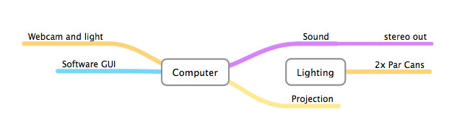

Full system Wiring
If wanting to get the most from the PUP system it is recommended to have the full system set-up, this will enable you to use more features and interact with the system in a more immersive way.
Below is an indication of how the system would be connected together.
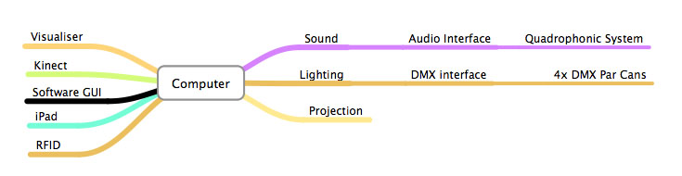
The guides below assume that you have installed the appropriate software on the mentioned devices.

Basic Set-up – Computer, Kinect and Speakers
Plug the Kinect into your computer using the USB cable and that it is plugged into a mains power socket.
Connect your speakers to your commuter through the headphones socket, it will most likely be a green round socket, if unsure refer to the manual for you device.
Once the hardware has been plugged in, turn on your commuter and start the software.
You will need to check that the devices have been recognised by selecting the correct devices from the drop down menus.
To allow you to see the controls for the software and have the display viewable you may want to connect a second display, to do this follow the instructions below:
Connect an HDMI or VGA cable to the HDMI or VGA port on your computer and then connect it to the display
On the display you will need to select the correct input source, probably 'Computer'.
Depending on the inputs and outputs of your hardware you may need video adapter, refer to the documentation for your specific hardware if unsure.

Full Set-up –
The full set-up described below use hardware components that may differ from items that you own, any other hardware will need to be configured as described in the manuals for those specific items.
Connect the USB hub to the left USB port on your computer and then connect the power lead for the USB hub.
N.B. - When connecting devices to the USB use the USB data ports and NOT the USB charging ports, these can be differentiated by the lightning icon above the charging ports.
Place the “Kinect” on a stable surface central to the viewing screen, plug the device into a power socket, the USB lead into a free USB port directly into the computer.
Next, connect the Webcam directly to the USB port on the computer (There can be issues when using USB hubs for webcams depending on driver conflicts and power draw requirements).
You can try using it through a USB hub, if problems arise try using it on a free USB port directly on the computer.
You can use a USB extension for extra reach, but if you go beyond 5m you will need an active cable or another powered USB hub.
Using a micro USB lead connect the DMX control box into the USB hub. You may need a 5 pin to 3 pin adapter depending on your hardware. Connect the other end of the XLR cable into the 'DMX in' port of the first DMX lighting fixture, to connect the other lighting fixtures connect an XLR cable from the DMX out of the first light to the DMX in of the second. Continue this process to daisy chain further DMX lighting fixtures.
To enable the DMX lights to function correctly you may need to select the channel on which they will operate, for the models provided it is done in the following way.
The specific way that your lighting channels operate may be different but could look something like the following.
Press the function button on the fixture so that it displays ADDR and then press enter, the first light fixture should be set to number one.
Repeat this process for the other fixtures, remember that the lights provided are six channel lights, this means that the second fixture will need to be set to channel 7. Below is a table showing the channel numbers if several six channel lights are used.
S mentioned your hardware may be different, if the channels on your hardware don’t conform to the following it is possible to alter them from within the PUP system to enable it to work.

Fixture Number | 1 | 2 | 3 | 4
Channel Number | 1 | 7 | 13 | 19

Connecting audio device
Connect the computer to your audio system using a 3.5mm jack lead and plug it into the computer. Alternatively you can send the audio through the HDMI lead and use the speakers on your display device.
To change the audio output device between HDMI and the built-in output you can click on the 'Audio Driver Settings' button in the computer based 'Audio System' section of the 'Pop up Play' software.
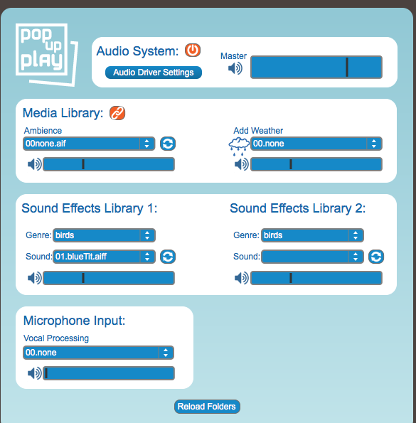

Installing MIRA app for use with the PUP system with an IPad
To enable a greater level of control and interaction it is possible to use the PUP system with an IPad, to allow this you will need to download and install an app called MIRA which can be downloaded from within ITunes or from within a browser window from the following link
https://itunes.apple.com/gb/app/mira-controller/id649586480?mt=8

Installing the App
If you are installing the app while using the device please follow these instructions:
Locate the MIRA app by searching on the ITunes store.
Select the MIRA app and read the app description to check if it is the correct one.
When ready select the button that has the price, this will start the installation process on your device.
You will need to enter your password for the iTunes store to allow it to install.
Once it as downloaded and installed go to your Apps and select MIRA.
When MIRA opens you will need to select the WI-FI network that your computer is connected to, once this has been done the PUP screen should open and be ready to use.
Note – You will need to have a bank card associated with your ITunes account to be able to purchase an app even if it is free.

Opening the PUP Software
Run the PUP software from you list of installed programs, once running it should open a control window and a black viewer window.
Drag the viewer window onto the connected display by clicking and dragging on the top of the viewer window and moving it off the screen towards the right.
When the window is fully on the correct display, press the “Esc” key to allow it to go into full screen mode.
Proceed to test that the software is running by selecting a background image from the background media library drop down menu.
Turn the “Kinect on using the power button on the control window and test that the video is coming through by having someone stand in front of the “Kinect”. To ensure that the “Kinect” can clearly see the subject, use the LED lighting panel to illuminate the front of the subject, adjust the brightness using the controls on the back of the device so that the subject can be clearly seen.
If there is no illumination on the subject they will still appear on screen but they will appear as a silhouette.
Note – when using the power button in the software the function differs between the IPad and the computer.
On the computer it turns the Kinect on and off, on the IPad it acts as a button that shows or hides the user.
Check to see if the Audio device is working by turning on your audio hardware and ensuring the volume is turned up.
Check to see if the Webcam is working by selecting the correct device from the list and turning it on.
Check that the lighting is working by going to the lighting controls and selecting a colour from the colour panel.
Remember to select the correct channels for the red, green and blue colours, refer to the lighting information above or the specific documentation for your hardware.
You may have to use the “Select Port” option to correctly use your device, to find out what port your hardware is connected to you may need to select “Print Port” to find out.
See 'Troubleshooting' section if anything is not working.

Connecting and using the IPad
Turn on the IPad and log in, proceed to open the app “MIRA” and the controls should appear, if not select the correct WI-FI network.

WI-FI Set-up
To use an IPad you will need to have it connected to the correct WI-FI network, if you have your computer connected to your home network then connect the IPad to the same network.
Depending upon the speed of your network you may want to create an ad-hoc network to improve IPad responsiveness with the PUP software, this will involve using DOS commands if using windows 8.
Use the below link and follow the guide carefully to create an ad-hoc network.
http://www.addictivetips.com/windows-tips/how-to-create-wireless-ad-hoc-internet-connection-in-windows-8/
If the controls still fail to appear refer to the troubleshooting section at the end of this document.

Using the PUP software on a computer
Scenes within the PUP system are comprised of audio, visual and lighting elements, this media library can be linked across the associated systems, or they can be unlinked so as to control each element individually.
There are some differences between the computer and iPad based controls. The iPad controls are in general simplified and have had most system settings removed so that they can be experimented with without causing problems to the running of the software.
Also the iPad offers pinch and rotation gestures which can be used in place of a scale fader and as a way of rotating visual elements within the X/Y position/scale/rotation control areas.
Within the PUP system a collection media such as backgrounds, overlays, sounds and puppets is known as a scene, scenes are comprised of the following elements

Background and weather system
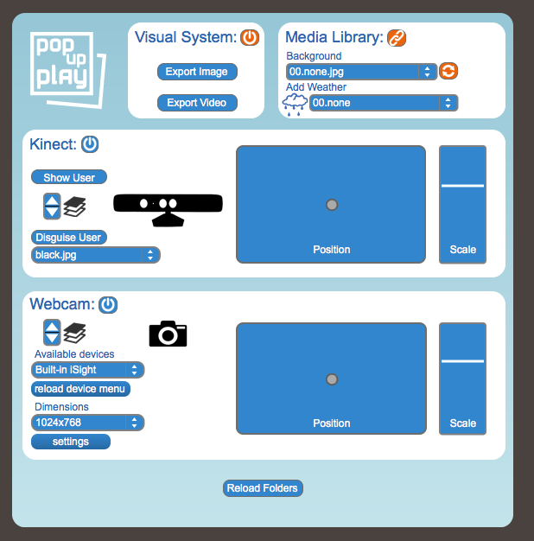
The background image can be selected from the drop down menu on the visual tab of the software.
From the drop down menus simply select a background and it will load.
The bank of backgrounds can be added to as described in the “Adding Media” Section.
You can add weather effects to the background from the “Add Weather” drop down menu.
This will overlay a weather effect to the background such as rain.
Images and movie content link to saved files that use the same name, these are loaded at the same time the image or video content is loaded.
Weather elements can be selected from either the sound or video systems and it will trigger them both.
By altering the backgrounds you can change how the scene feels and create a story that progresses from location to location.

Overlay systems
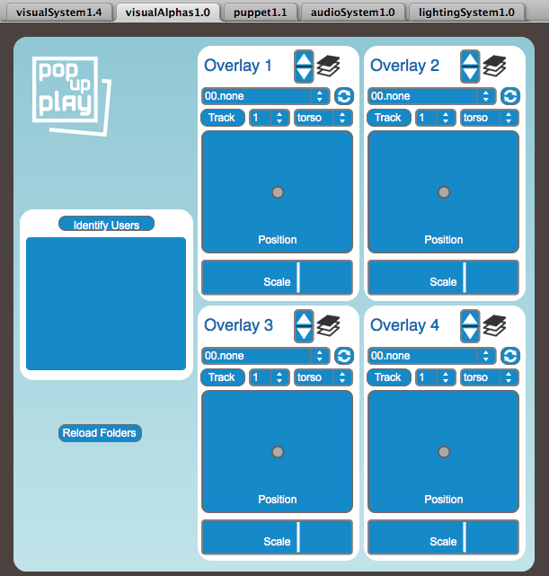
Overlays allow you to place objects within the scene, these objects can then be tracked to body parts or simply moved around using the control panel for the particular overlay.
The overlays are selected from the drop down menu and will load once selected.
If there are multiple users you can assign overlays to each user, you can also add multiple overlays to a single user.
Simply click the “Identify users” button and then in the drop down menu next to the Track button select the appropriate user.
It is good to unselect the 'Identify users' button when not in use as it can save system resources, but depending on your computer it may not be necessary, refer to the minimum system specifications to see if your system meets them.
Once an overlay has been selected you can continue to assign the overlay to a specified body section which can be selected from the drop down menu for the overlay.
It is important to note that when a user exits and re-enters the scene, their user number may change, it is good to mark out the area of view on the floor to help people stay in/out of the field of view.
The position of the overlay can be adjusted from the “Position” box, you can have the overlay track a body part and still move it within the scene, this gives you control over overlay items such as helmets or other costume items to make sure they are in the correct position.
Overlays can be scaled in size, simply drag the “Scale” slider for the selected overlay, this allows you to make sure that elements such as costume items fit the user correctly.

Puppet Systems
Similar to how the overlay systems work you can place “Puppets” within the scene
These puppets use the information from the Kinect to allow the user to actively move the puppet, the movement of the puppet relates to the users movements, for example if the user moves their arm, the puppets arm will move.
You can change the placement and scale of the puppet in the same way that you can change the position and scale of overly items.
To select a puppet go to the puppet section of the software and select one from the drop down menu.
Puppets can be created and added to the library of available puppets by following the instructions in the “Adding Puppets” Section.
When a puppet is being used you may not want to have the image of the user displayed, you can hide the user from the scene and keep the puppet on screen, this allows the user to perform alongside the puppet or be replaced by it.

Using the PUP software on an IPad
The controls for using the PUP software on an IPad are slightly different to that of the computer based controls, they have been simplified and restricted so that if you want to allow children to use the system and change items they can do so without altering any of the important settings such as the camera source.

Using the Visual system on the IPad
The visual system on the IPad has most of the functionality that the commuter controls do but without the ability to change the camera or Kinect settings.
Note – when using the power button in the software the function differs between the IPad and the computer.
On the computer it turns the Kinect on and off, on the IPad it acts as a button that shows or hides the user.
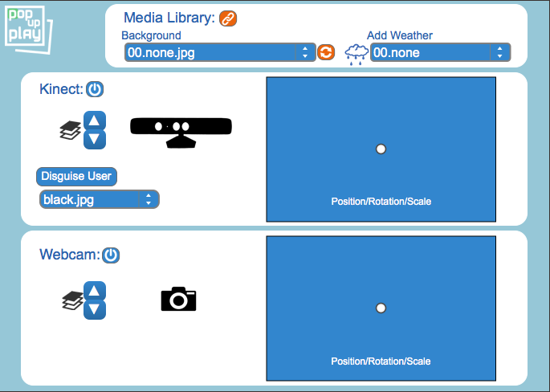

IPad Background Controls
On the IPad you can change the background from the drop down menu underneath “Background”.

IPad Weather Controls
The weather systems are changed by selecting one from the drop down menu underneath “Weather”.

IPad Kinect Controls
As with the computer controls you can change the layer order of items by selecting the up or down arrows.
You can choose to disguise the user by selecting one of the pre-sets from the drop down menu, these disguises hide the normal image and overlay a pattern over the users shape, refer to the “Adding media to the library” section to see about using your own textures.
The Scale slider has been removed but the functionality has been moved into the square within the Kinect section.
Instead of using a slider to change the scale you need to use two finger gestures, simply place two fingers on the square and move them apart from each other to scale the object up and increase its size, move them together to reduce the scale and decrease its size.
To rotate elements place two fingers on the square slightly apart and rotate your hand.

Adding media to the library
It is possible to add your own media element to the system for use, to do this you will need to place items in the correct folders and adhere to the correct file formats for each particular element.

Overlays
Overlay items that can be placed within the scene must be PNG files, these allow for a transparency element.
If unsure of if a file is a PNG file open its properties tab to check, it is possible to convert images to PNG files or create your own using a program such as Photoshop or Gimp which is free.
The overlay items must be placed in the “alphas” folder where the media library has been installed.

Sound Effects
Sounds effects such as the sound of thunder can be added by placing them in the “FX” folder and placing them in one of the three folders within.
You can create your own folders within the folder location, these folders become the “Genre” drop down menu.
There are restrictions as to what file types are supported at present, use only AIFF files or WAV files saved with 16Bit 44.1 KHz settings, if you place any other audio files within the folders they may not play or be picked up by the software.

Lighting Ambience and Saves
To allow you to recall lighting settings it is possible to save the settings while in a session, simply click the “Save” button on the lighting system tab and it will save a compatible file.
To load any saved setting simply click the “recall” button and select the .jit file that you want to load.

Puppet System
It is possible to change the puppet that you have loaded, it is also possible to Crete and add your own to the media library.
To do this you must name the files in a specific way as outlined her and in the “Read Me” document within the puppet media folder. Create a folder for your puppet and name it, this is the name that will show up in the puppet system drop down menu, and save the following files in it

Files must be named in the following way:
calfL.png
calfR.png
foreArmL.png
foreArmR.png
head.png
thighL.png
thighR.png
torso.png
upperArmL.png
upperArmR.png

As with the overlay items images that are being used for the puppet system MUST be saved as .PNG files, these allow for certain areas of the image to be made transparent so that only the areas you want are viewable.
If unsure of how to save files as .PNG format it is recommended that you look into programs such as Photoshop or Microsoft Paint.

Sounds
To enable you to increase the options with background ambience sounds you can add your own.
Place the files into the “Sounds” folder and they should be picked up by the system on start or if you press the “Reload Folders” button.
As with the sound effects files you must ensure that they are saved in the correct format, either AIFF or WAV, files such as MP3 may not be found or play.

Textures
When using a Kinect with the PUP system it is possible to mask the user with a texture, you can add your own texture by placing it in the “Textures” folder.
Texture files can be saved as any of the major image file formats such as JPEG, PNG or GIF.

Backgrounds
The background visual is often the biggest visual element within a scene, it is possible to use your own images by placing them into the “Visuals” folder.
These images can be in any of the main image file formats as mentioned above.
Images will adapt to the screen resolution but high resolution images may reduce performance on your system.
If you want to use an image that is not at this resolution it is possible to resize it by using either Photoshop, Gimp or by using a tool such as “Image Resizer for Windows”

Weather
It is possible to add weather effects such as rain or lighting, to do this add the video file which should be in .MOV format and the relevant sound file into the “Weather” folder.
The video will need to have a transparency layer in order to overlay the background. This means you are restricted to certain codecs with an alpha channel, Refer to the “Image and Video Codecs” section for more information.
Movies with alpha channels can be significantly larger and more intensive to play, remember to check that your system meets the system specifications.
Note that the video and sound files must be called the same name and audio files must be saved in a compatible format such as WAV or AIFF.
Once items are placed in this folder refresh the media library within the software and your files should show up.

Troubleshooting
The following questions and answers can guide you through overcoming some of the issues that may be face when setting up and using the software.

The DMX lighting isn’t working
This can happen when the correct port isn’t selected, to do this press “cmd+ M” when the control window is selected to open the “max window”. Click “Print Ports” to display what ports are there and select the port letter that the device “ENVX4” is on.
You should get a message saying “connected to device, status 1” and the LED on the DMX control box should be alternating between green and blue.

The Webcam Isn’t working
The DMX control box and the webcam can cause a conflict, to resolve this issue, ensure that the webcam is plugged into the computer directly and not through the USB hub and that the DMX control box is plugged into the USB hub.
Also, make sure you have pressed the 'Reload Devices' button and selected the correct device from the drop down menu.

There are no controls on the IPad
To resolve this close the “MIRA” and re-open it. In extreme cases, restart the MIRA app on the iPad and the PUP app on the computer, if you still have issues then restart both devices.
Performance between the IPad and the computer can be restricted by the speed of your home network, creating an ad-hoc network may fix this.

My connected display is not showing up
Ensure that the cables are fully plugged in, if so try restarting your computer.
If this fails to show your connected display check your display setting in the control panel of your computer and check that the computer is configure to recognise external displays.
If problems persist refer to the manual for your display.

The PUP software fails to install on windows
The software isn’t digitally signed by windows so an error message may appear asking if you want to install it. Click proceed and follow the instructions given.
Ensure that you have installed any relevant updates for your computer and try installing the software again.

Additional information

Kinect for XBOX
It is possible to use the PUP system with a Kinect from and XBOX, this use though should only be done by developers, if you are a developer and are interested in using the system in this way please contact us for more information.

File formats and conversion
As mentioned in previous sections the PUP software only supports certain file types for specific elements, these formats must be followed to ensure that the system works and that media is found.
If you need to convert media from one format to another you will need to download and install software that is capable of doing this.
Freemake provide converters for audio and video files, if you want to also edit files in any way Audacity is a free audio editor that can also convert files.
You can also use downloaded sounds from sites such as Freesound.org.
For image files Microsoft paint or GIMP can provide options to save files in the correct formats.

